Camera Calibration

Task description:

1. Camera calibration i.e. compute #mm/ pixel object displacement

2. Calculate horizontal field of view in degrees of angle.

3. Calculate theoretical values (FOV) and compare with measured values.

Method:

1. Identifying the position of button on clothing, i.e., green circle in Fig. 1. This can be easily done by 小畫家.

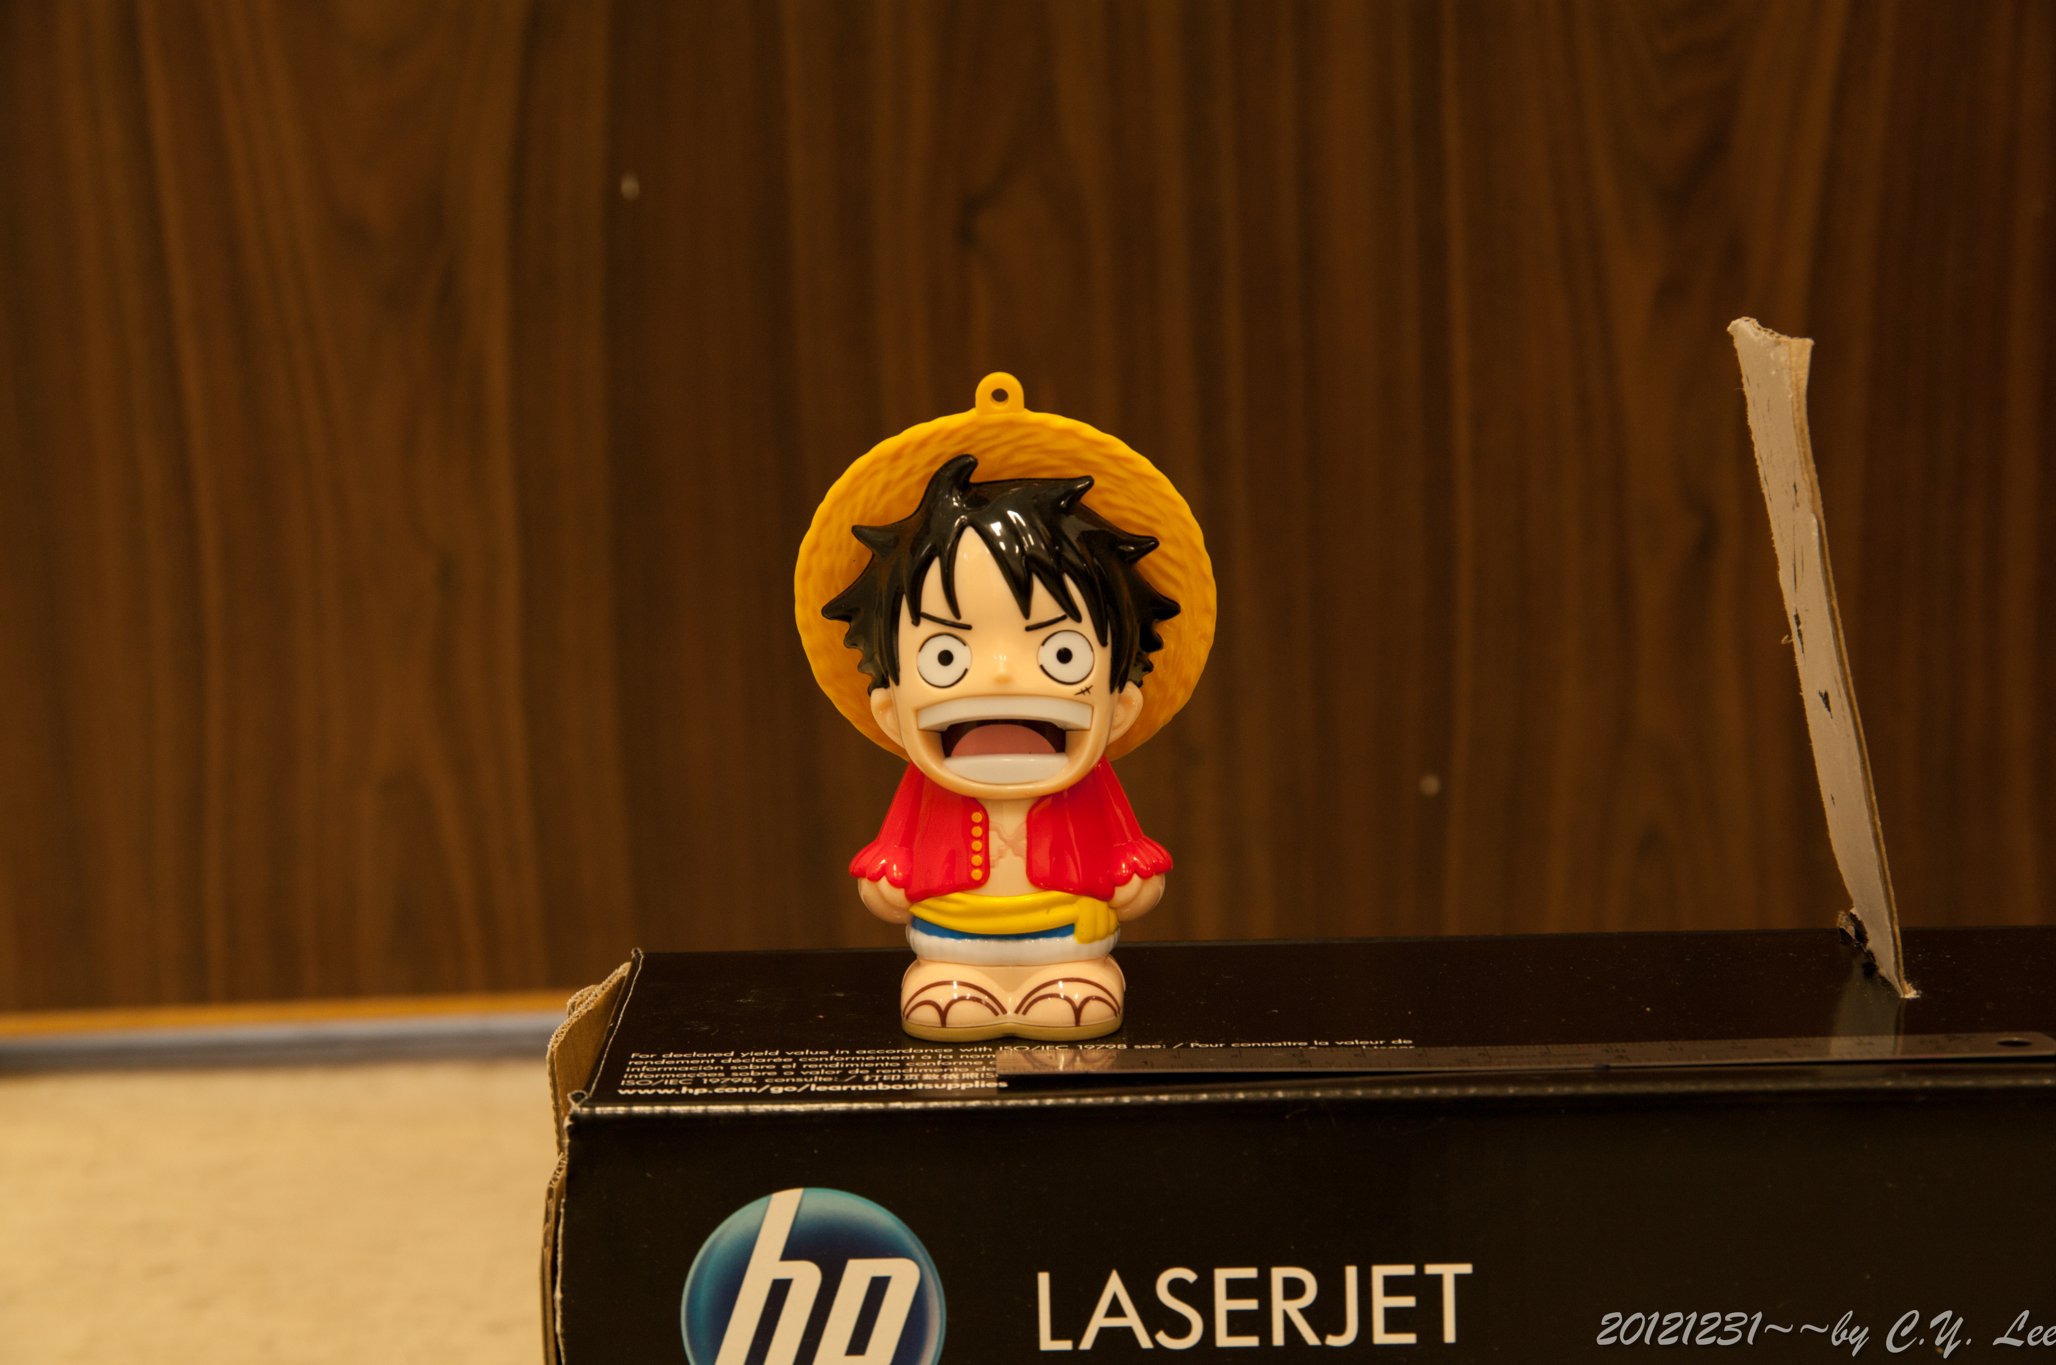

Figure 1

1. Based on the movement on x-axis, we can calculate the displacement.
2. Then we can calculate horizontal field of view in degrees of angle using formula shown below: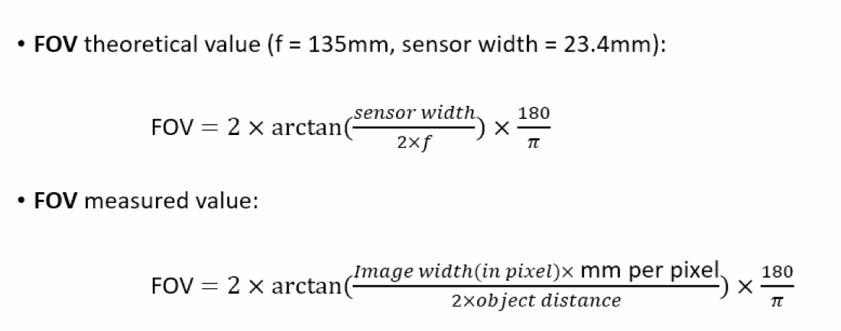

Experiment results:

